**Project Coversheet**

|  |  |
| --- | --- |
| Full Name | Savil Rosario |
| Email | [rosariosavil1905@gmail.com](mailto:rosariosavil1905@gmail.com) |
| Contact Number | 0892217344 |
| Date of Submission | 05/07/2025 |
| Project Week | Week 1 |

**Project Guidelines and Rules**

**1. Submission Format**

* **Document Style**:
  + Use a clean, readable font such as *Arial* or *Times New Roman*, size 12.
  + Set line spacing to **1.5** for readability.
* **File Naming**:
  + Use the following naming format:  
    Week X – [Project Title] – [Your Full Name Used During Registration]  
    *Example*: Week 1 – Customer Sign-Up Behaviour – Mark Robb
* **File Types**:
  + Submit your report as a **PDF**.
  + If your project includes code or analysis, attach the **.ipynb notebook** as well.

**2. Writing Requirements**

* Use formal, professional language.
* Structure your content using headings, bullet points, or numbered lists.

**3. Content Expectations**

* Answer **all** parts of each question or task.
* Reference tools, frameworks, or ideas covered in the programme and case studies.
* Support your points with practical or real-world examples where relevant.
* Go beyond surface-level responses. Analyse problems, evaluate solutions, and demonstrate depth of understanding.

**4. Academic Integrity & Referencing**

* All submissions must be your own. Plagiarism is strictly prohibited.
* If you refer to any external materials (e.g., articles, studies, books), cite them using a consistent referencing style such as APA or MLA.
* Include a references section at the end where necessary.

**5. Evaluation Criteria**

Your work will be evaluated on the following:

* Clarity: Are your answers well-organised and easy to understand?
* Completeness: Have you answered all parts of the task?
* Creativity: Have you demonstrated original thinking and thoughtful examples?
* Application: Have you effectively used programme concepts and tools?
* Professionalism: Is your presentation, language, and formatting appropriate?

**6. Deadlines and Extensions**

* Submit your work by the stated deadline.
* If you are unable to meet a deadline due to genuine circumstances (e.g., illness or emergency), request an extension **before the deadline** by emailing:  
  [**support@uptrail.co.uk**](mailto:support@uptrail.co.uk)

Include your full name, week number, and reason for extension.

**7. Technical Support**

* If you face technical issues with submission or file access, contact our support team promptly at [**support@uptrail.co.uk**](mailto:support@uptrail.co.uk)**.**

**8. Completion and Certification**

* Certificate of Completion will be awarded to participants who submit at least two projects.
* Certificate of Excellence will be awarded to those who:
  + Submit all four weekly projects, and
  + Meet the required standard and quality in each.
* If any project does not meet expectations, you may be asked to revise and resubmit it before receiving your certificate.

**Week 1 – Customer Sign-Up Behaviour   
Savil Rosario**

**Task 1: Load and Clean the Data**

**Missing Values & Inconsistencies**

* **customer_id**: Two missing values were identified and filled using sequential logic, maintaining consistency with existing IDs.
* **name**: Missing entries were populated by extracting names from the email address where possible. Remaining nulls were labeled as "Not Specified".
* **email**: Null and blank values were replaced with "Not Specified".
* **signup_date**: Non-date strings, blanks, and missing values were coerced to NaT and filled using the column's median date.
* **region**: Missing values were replaced with "Unknown".
* **age**: The string "thirty" was converted to numeric (30), the outlier 206 was removed, and both null and "unknown" values were filled using the column median.
* **gender**: Inconsistent and invalid entries (e.g., blank, 123) were replaced with "Other" to maintain clean categorical data.
* **marketing_opt_in**: Inconsistent entries like null, "Nil", and "none" were standardized to False, while "yes" was mapped to True.
* **plan_selected**: Text values were standardized to a consistent set: "Basic", "Pro", "Premium" and "Unknown Plan"
* **source**: Blank entries and those containing "??" were replaced with "Unknown".

**Duplicates & Data Types**

* Checked for and removed duplicate rows based on customer_id, treated as a primary key.
* Reviewed and updated data types for all columns to ensure they match their expected formats (e.g., datetime for signup_date, category for plan_selected).

**Fig:1.1-Dataset summary Before:**

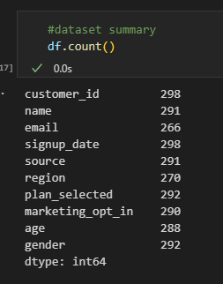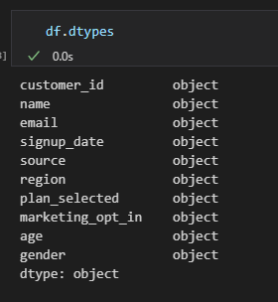

**Fig:1.2-Dataset summary After**

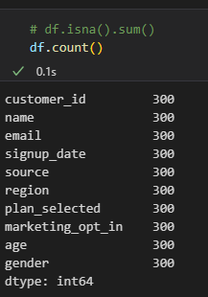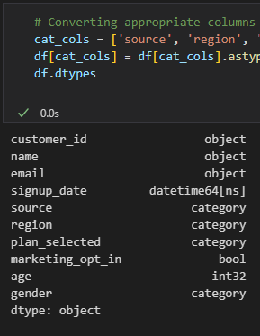

**Task 2. Data Quality Summary**

* 1. **Count of Missing values per column**

The analysis confirms that there are no missing values in any column. This is the result of a prior data cleaning process, during which all missing entries were identified and filled with appropriate and context-relevant values. The dataset is therefore complete and ready for further analysis.

**Fig:2.1a-Missing Values Before**

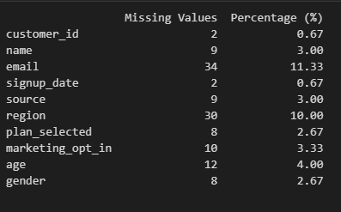

**Fig:2.1b-Missing Values After**

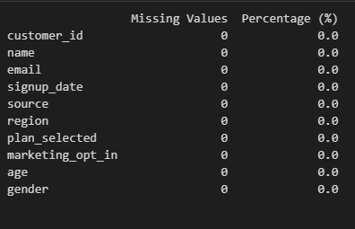

* 1. **Number of Duplicates Removed**

The analysis found no duplicate entries, indicating that the dataset contains only unique records.

**Fig 2.2a**

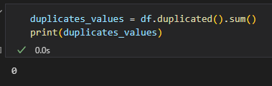

* 1. **Inconsistent Category Values Corrected**

To ensure consistency in categorical data, several corrections were applied across relevant columns:

* In the source column, ambiguous entries labeled as "??" were standardized to Unknown.
* In the plan_selected column, variations in plan names such as "prem", "PREMIUM", "PRO", "Basic", and "UnkownPlan" were normalized to lowercase values: premium, pro, basic, and unkownplan, respectively.
* The gender column values were also converted to lowercase to maintain uniform formatting.

**Task 3. Summary Outputs**

**3.1 Sign-ups per week (grouped by signup_date)**

Week 22 recorded the highest number of sign-ups with 14, while all other weeks had either 6 or 7 sign-ups. Overall, the unique weekly sign-up counts were 14, 7, and 6.

**Fig 3.1a**

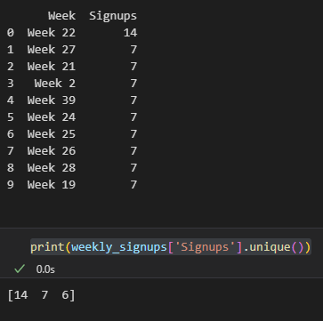

**3.2** **Sign-ups by source, region, and plan_selected**

**3.2.a Sign-ups by Source**

Google leads with 50 sign-ups, followed closely by Youtube (58) and Instagram (49). Facebook and Referral sources also show strong engagement, while Unknown accounts for the lowest sign-ups at 15.

**Fig: 3.2.a**

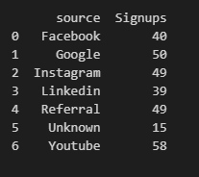

**3.2.b Sign-ups by Region**

The North region has the highest sign-ups at 65, with East (61) and South (59) also performing well. Unknown regions have 30 sign-ups, indicating some missing location data.

**Fig: 3.2.b**

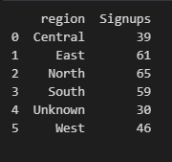

**3.2.c Sign-ups by Plan Selected**

The Premium plan is the most popular with 100 sign-ups, followed by Pro (94) and Basic (92). The UnknownPlan category has the fewest sign-ups at 14.

**Fig: 3.2.c**

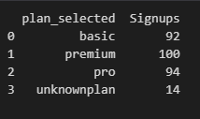

**3.3 Marketing opt-in counts by gender**

Across all gender categories, more customers chose not to opt in to marketing communications.

* Males had the highest number of opt-outs (55), followed by Females (48).
* Non-Binary and Other genders also showed higher opt-out counts than opt-ins.
* Overall, marketing opt-in rates were lower than opt-out rates across all groups**.**

**Fig 3.3.a Group by Marketing and Gender**

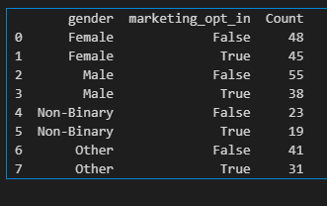

**3.4 Age summary: min, max, mean, median, null count**

* Customer ages range from a minimum of 21 to a maximum of 60 years.
* The average (mean) age is 35.4, and the median age is 34, indicating a fairly even distribution.
* There are no missing values in the age column.

**Fig 3.4.a Column Age Summary**

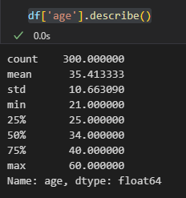

**Fig 3.4.b Column Age Null Values**

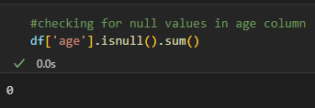

**Task 4. Business Questions**

**4.1 Which acquisition source brought in the most users last month?**

An analysis of the signup_date column shows that October 2024 was the most recent month with recorded customer signups. During this month, Google emerged as the leading acquisition source, contributing the highest number of new users with a total of 7 signups. This highlights the effectiveness of Google-related marketing or referral strategies in that period**.**

**4.2 Which region shows signs of missing or incomplete data?**

An analysis of customer records flagged for incomplete information revealed notable differences across regions. The North region had the highest proportion of incomplete records at 27.7%, followed by the Unknown region at 23.3% and the West at 21.7%.

These findings suggest that the North region may have the most significant data quality issues, potentially impacting insights or decisions based on regional segmentation.

**Fig 4.2.a**

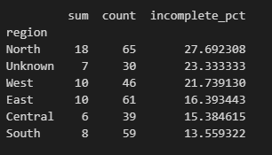

**4.3 Are older users more or less likely to opt in to marketing?**

To investigate whether older users are more or less likely to opt in to marketing, I analyzed the age distribution across marketing opt-in statuses using descriptive statistics, boxplots, and a t-test for statistical significance.

* The mean age for users who opted in was 35.83, while those who opted out had a mean age of 35.08—a minimal difference.
* A boxplot showed very similar age distributions across both groups, with nearly identical medians and interquartile ranges.
* A t-test returned a p-value of 0.548, indicating no statistically significant difference in age between the two groups.

**Conclusion:**  
There is no meaningful evidence to suggest that age influences a user's likelihood to opt in to marketing.

**Fig 4.3.a Descriptive Statistics**

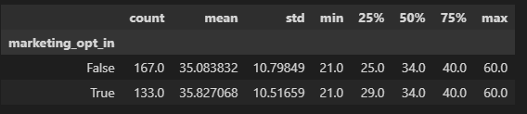

**Fig 4.3.b Boxplot**

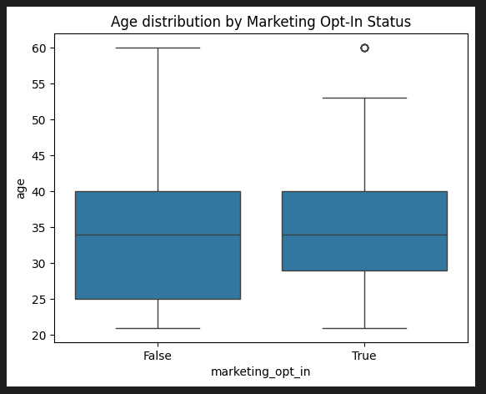

**Fig 4.3.c T-Test**



**4.4 Which plan is most commonly selected, and by which age group?**

The analysis of plan selection across different custom age groups reveals distinct preferences among users:

* Age Group 20-30: This group shows a fairly balanced distribution of plan choices with 40 users selecting the Basic plan, 38 opting for Premium, and 41 choosing the Pro plan. This suggests a diverse preference for plan types among younger users.
* Age Group 31-40: Premium is the most popular plan in this group, with 43 users selecting it, followed closely by Basic (33) and Pro (32). This indicates a slight leaning towards Premium plans among middle-aged users.
* Age Group 41-50: Plan selection is notably lower in this group overall. Premium plans are preferred here as well, with 9 users, compared to 5 for Basic and 6 for Pro.
* Age Group 51-60: This group has a relatively balanced plan selection, with 14 users choosing Basic, 10 Premium, and 15 Pro, showing no strong preference for any specific plan.

Overall, the Premium plan tends to be favoured slightly more among middle-aged users, while younger and older groups show a more balanced distribution across all plans.

**Fig 4.4.a**

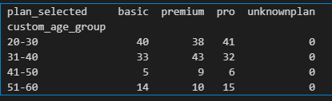

**Fig 4.4.b**

